CPE301 – SPRING 2019

Design Assignment 4B

Student Name: Alex Cater

Student #: 2000583031

Student Email: cater@unlv.nevada.edu

Submit the following for all Labs:

1. In the document, for each task submit the modified or included code (only) with highlights and justifications of the modifications. Also, include the comments.
2. Use the previously create a Github repository with a random name (no CPE/301, Lastname, Firstname). Place all labs under the root folder ESD301/DA, sub-folder named LABXX, with one document and one video link file for each lab, place modified asm/c files named as LabXX-TYY.asm/c.
3. If multiple asm/c files or other libraries are used, create a folder LabXX-TYY and place these files inside the folder.
4. The folder should have a) Word document (see template), b) source code file(s) and other include files, c) text file with youtube video links (see template).

1. **COMPONENTS LIST AND FLOW DIAGRAMS**

Atmega328PB Xplained Mini

Micro USB Cable (Power Supply)

Breadboard

Multifunction Shield (Potentiometer)

ULN2003 w/ LEDs

Stepper Motor

Servo Motor

Female to Female Wires

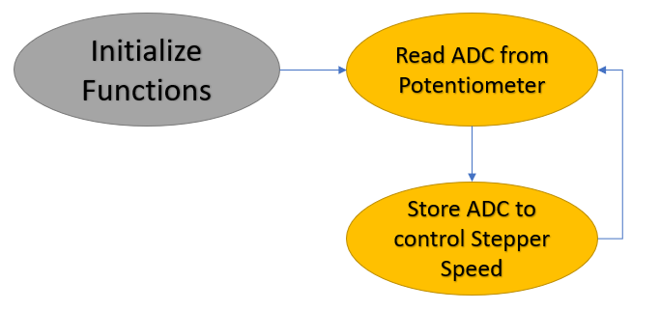

*Figure 1 – Flow Chart for Coding Algorithm in Task 1*

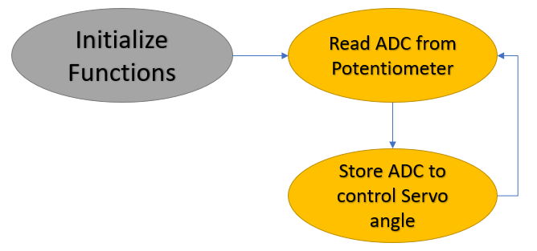

*Figure 2 – Flow Chart for Coding Algorithm in Task 2*

1. **INITIAL/DEVELOPED CODE OF TASK 1**

|  |
| --- |
|  |
| /* |
|  | * DA4B_T1.c |
|  | * |
|  | * Created: 5/2/2019 5:07:18 PM |
|  | * Author : acate |
|  | */ |
|  |  |
|  | #define F_CPU 16000000UL |
|  | #include <avr/io.h> |
|  | #include <stdio.h> |
|  | #include <avr/interrupt.h> |
|  | #include <util/delay.h> |
|  |  |
|  | #define BAUDRATE 9600 |
|  | #define BAUD_PRESCALLER ((F_CPU / (BAUDRATE * 16UL)) - 1) |
|  |  |
|  | void Timer0_init(void); |
|  | void read_adc(void); |
|  |  |
|  | void USART_init(void); |
|  | unsigned char USART_receive(void); // Receive Serial data from UDR0 |
|  | void USART_send(unsigned char data); // Send individual char in UDR0 |
|  | void USART_putstring(char* StringPtr); // Break string into chars and send |
|  |  |
|  | volatile float adc_val; // Store ADC Value representing Analog Voltage |
|  | char outs[20]; // Store float values into array of chars |
|  |  |
|  | int main(void) { |
|  |  |
|  | DDRC = 0x00; // Inputs: PC7:0 (PC0 Input ADC, PC1 Switch) |
|  | PORTC = (1<<DDC1); // Set pull-up for PC1 |
|  | DDRB |= (1 << DDB0)|(1 << DDB1)|(1 << DDB2)|(1 << DDB3); // Outputs: PB3:0 |
|  |  |
|  | Timer0_init(); // Call the Timer0/PWM initialization// |
|  | adc_init(); // Call the ADC initialization code |
|  | USART_init(); // Call the USART initialization code |
|  | USART_putstring("Connected!\r\n"); // Pass 'Connected!' to function |
|  | _delay_ms(125); // Wait a bit |
|  |  |
|  | while (1) { |
|  | read_adc(); |
|  | snprintf(outs,sizeof(outs),"%3f", adc_val); // Store 'adc_val' into 'outs' |
|  | USART_putstring(outs); // Pass 'outs' to function |
|  | _delay_ms(250); |
|  |  |
|  | if (adc_val >= 242) { // If 'adc_val >= 242'... |
|  | OCR0A = 242; // Cap Duty Cycle at 95% |
|  | USART_putstring(", 95%\r\n"); // |
|  | } else if ((adc_val<242) & (adc_val >= 5)) { // Else, if '5 <= adc_val < 242'... |
|  | OCR0A = adc_val; // Duty Cycle '%' matches adc_val |
|  | USART_putstring(", "); |
|  | adc_val = (adc_val/255)*100; |
|  | snprintf(outs,sizeof(outs),"%3f", adc_val); // Stores integer 'adc_temp' into the string 'outs' |
|  | USART_putstring(outs); // Pass 'outs' to function to send serial of chars |
|  | USART_putstring("%\r\n"); |
|  | } else if (adc_val < 5) { // Else, if ' adc_val < 5'... |
|  | OCR0A = 0; // Drop Duty Cycle to 0% |
|  | USART_putstring(", 0%\r\n"); |
|  | } |
|  |  |
|  | PORTB=0x09; |
|  | while (TCNT0 != OCR0A); |
|  | PORTB=0x0C; |
|  | while (TCNT0 != OCR0A); |
|  | PORTB=0x06; |
|  | while (TCNT0 != OCR0A); |
|  | PORTB=0x03; |
|  | while (TCNT0 != OCR0A); |
|  | } |
|  | return 0; |
|  | } |
|  |  |
|  |  |
|  |  |
|  | void Timer0_init(void) { |
|  | TCCR0A |= (1 << WGM01); |
|  | TCCR0B |= (1 << CS02) | (1 << CS00); |
|  | } |
|  |  |
|  | void USART_init(void) { |
|  | UBRR0H = (uint8_t)(BAUD_PRESCALLER >> 8); // Store Upper Baudrate values into UBRR0H |
|  | UBRR0L = (uint8_t)(BAUD_PRESCALLER); // Store Lower Baudrate values into UBRR0L |
|  | UCSR0B = (1 << RXEN0) | (1 << TXEN0); // Enable Receiver and Enable Transmitter |
|  | UCSR0C = (3 << UCSZ00); // Set UCSZ02:1 as 8-bit character data |
|  | } |
|  |  |
|  | unsigned char USART_receive(void) { // Function to receive ASCII value from UDR0 |
|  | while (!(UCSR0A & (1 << RXC0))); // Keep Checking until RXC0 is 'High' to break loop |
|  | return UDR0; // Return received serial into unsigned char data |
|  | } |
|  |  |
|  | void USART_send(unsigned char data) { // Function to transmit ASCII value into UDR0 |
|  | while (!(UCSR0A & (1 << UDRE0))); // Keep Checking until UDRE0 data register 'High' to break loop |
|  | UDR0 = data; // Store unsigned char serial data into UDR0 |
|  | } |
|  |  |
|  | void USART_putstring(char* StringPtr) { // Function to break string into chars, then USART_send() |
|  | while (*StringPtr != 0x00) { // Keep Looping until String Completed (null/0-bits) |
|  | USART_send(*StringPtr); // Send the unsigned char value pointed by the string pointer |
|  | StringPtr++; // Increment pointer to next char array location |
|  | } |
|  | } |
|  |  |
|  |  |
|  | void adc_init(void) { |
|  | DIDR0 = 0x3F; |
|  |  |
|  | ADMUX = (0<<REFS1)|(1<<REFS0)| // Reference Selection Bits, AVcc - External cap at AREF |
|  | (0<<ADLAR)| // ADC Left Adjust Result for 10-bit result |
|  | (0<<MUX3)|(0<<MUX2)|(0<<MUX1)|(0<<MUX0);// Analog Channel Selection Bits 'ADC0' (PC0) |
|  |  |
|  | ADCSRA = (1<<ADEN)| |
|  | (0<<ADSC)| // ADC Start Conversion |
|  | (0<<ADATE)| // ADC Auto Trigger Enable |
|  | (0<<ADIF)| // ADC Interrupt Flag |
|  | (0<<ADIE)| // ADC Interrupt Enable |
|  | (1<<ADPS2)|(0<<ADPS1)|(1<<ADPS0); // ADC Prescaler Select Bits '32' |
|  | } |
|  |  |
|  | void read_adc(void) { |
|  | unsigned char i = 1; // Set 'i' for iterations |
|  | adc_val = 0; // set float 'adc_val' |
|  | while (i--) { // Decrement 'i' until 4 samples take |
|  | ADCSRA |= (1<<ADSC); // If ADSC is high (ADC Start Conversion)... |
|  | while (ADCSRA & (1<<ADSC)); // Start the ADC Conversion |
|  | adc_val += ADC; // Store the analog value on of current adc_val |
|  | _delay_ms(50); // delay 50ms for sampling |
|  | } |
|  | adc_val = (adc_val); // Average of 4 samples taken into adc_val |
|  |  |
|  | adc_val = (adc_val - 512)/2; // Lets 10-bit Analog voltage become 8-bit value |
|  | } |
|  |  |

1. **INITIAL/DEVELOPED CODE OF TASK 2**

|  |
| --- |
|  |
| /* |
|  | * DA4B_T2.c |
|  | * |
|  | * Created: 5/3/2019 10:08:15 AM |
|  | * Author : acate |
|  | */ |
|  |  |
|  |  |
|  |  |
|  | #define F_CPU 16000000UL // Frequency of Xplained Mini (16MHz) |
|  | #include <avr/io.h> // Standard AVR Library |
|  | #include <stdio.h> // AVR library containing printf functions |
|  | #include <avr/interrupt.h> // AVR library containing interrupt functions |
|  | #include <util/delay.h> // AVR library containing _delay_ms() function |
|  |  |
|  | #define BAUDRATE 9600 // Baudrate (bps) |
|  | #define BAUD_PRESCALLER ((F_CPU / (BAUDRATE * 16UL)) - 1) // Baudrate Prescaler |
|  |  |
|  | void Timer1_init(void); // Initialize Timer1 properties |
|  | void adc_init(void); // Initialize Analog to Digital Converter |
|  | void read_adc(void); // Read value received from ADC |
|  |  |
|  | void USART_init(void); // Initialize USART |
|  | unsigned char USART_receive(void); // Receive Serial data from UDR0 |
|  | void USART_send(unsigned char data); // Send char data into UDR0 |
|  | void USART_putstring(char* StringPtr); // Break string into chars, send |
|  |  |
|  | volatile float adc_val; // Stores ADC Value |
|  | char outs[20]; // Store float value into array of chars |
|  |  |
|  | int main(void) { |
|  |  |
|  | DDRC = 0x00; // PC7:0 Inputs (PC0 Read ADC, PC1 Switch) |
|  | PORTC = (1<<DDC1); // Set pull-up for PC1 |
|  | DDRB |= (1 << 1); // OC1A for ATmega328PB = PB1 |
|  |  |
|  | Timer1_init(); // Call the Timer1/PWM initialization |
|  | adc_init(); // Call the ADC initialization code |
|  | USART_init(); // Call the USART initialization code |
|  | USART_putstring("Connected!\r\n"); // Pass "Connected!" to function |
|  | _delay_ms(125); // Wait a bit |
|  |  |
|  | while (1) { // Infinite loop |
|  | read_adc(); // Read ADC Value |
|  | ICR1 = 39999; // Set TOP count for timer1 in ICR1 |
|  | snprintf(outs,sizeof(outs),"%3f\r\n", adc_val); // Store 'adc_val' in 'outs' |
|  | USART_putstring(outs); // Pass "outs" to function |
|  |  |
|  | if (adc_val >= 3999) { // If 'adc_val >= 3999'... |
|  | TCNT1 = 0; // Reset Timer1 |
|  | OCR1A = 3999; // Set timer1 to position 180 degrees |
|  | _delay_ms(100); // delay |
|  | } else if ((adc_val < 3999) & (adc_val >= 1999)) { // If between range |
|  | TCNT1 = 0; // Reset Timer1 |
|  | OCR1A = adc_val; // Set timer1 to position ADC based value |
|  | _delay_ms(100); // delay |
|  | } else if (adc_val < 1999) { // If 'adc_val < 1999'... |
|  | TCNT1 = 0; // Reset Timer1 |
|  | OCR1A = 1999; // Set timer1 to position 0 degrees |
|  | _delay_ms(100); // delay |
|  | } |
|  | } |
|  | } |
|  |  |
|  |  |
|  |  |
|  | void Timer1_init(void) { // Initialize Timer0 properties |
|  | TCCR1A = (1 << COM1A1) | (1 << WGM11); |
|  | TCCR1B = (1 << WGM13) | (1<< WGM12) | (1 << CS11); |
|  | } |
|  |  |
|  |  |
|  |  |
|  | void USART_init(void) { // Initialize USART properties |
|  | UBRR0H = (uint8_t)(BAUD_PRESCALLER >> 8); // Store Upper Baudrate in UBRR0H |
|  | UBRR0L = (uint8_t)(BAUD_PRESCALLER); // Store Lower Baudrate in UBRR0L |
|  | UCSR0B = (1 << RXEN0) | (1 << TXEN0); // Enable Receiver and Transmitter |
|  | UCSR0C = (3 << UCSZ00); // Set UCSZ02:1 as 8-bit char |
|  | } |
|  |  |
|  | unsigned char USART_receive(void) { // Function to receive ASCII value from UDR0 |
|  | while (!(UCSR0A & (1 << RXC0))); // Keep Checking until RXC0 is 'High' to break loop |
|  | return UDR0; // Return received serial into unsigned char data |
|  | } |
|  |  |
|  | void USART_send(unsigned char data) { // Function to transmit ASCII value into UDR0 |
|  | while (!(UCSR0A & (1 << UDRE0))); // Keep Checking until UDRE0 data register 'High' to break loop |
|  | UDR0 = data; // Store unsigned char serial data into UDR0 |
|  | } |
|  |  |
|  | void USART_putstring(char* StringPtr) { // Function to break string into chars, then USART_send() |
|  | while (*StringPtr != 0x00) { // Keep Looping until String Completed (null/0-bits) |
|  | USART_send(*StringPtr); // Send the unsigned char value pointed by the string pointer |
|  | StringPtr++; // Increment pointer to next char array location |
|  | } |
|  | } |
|  |  |
|  |  |
|  | void adc_init(void) { |
|  | DIDR0 = 0x3F; // Disable Digital Input |
|  |  |
|  | ADMUX = (0<<REFS1)|(1<<REFS0)| // Reference Selection Bits, AVcc - External cap at AREF |
|  | (0<<ADLAR)| // ADC Left Adjust Result for 10-bit result |
|  | (0<<MUX0); // Analog Channel Selection Bits 'ADC0' (PC0) |
|  |  |
|  | ADCSRA = (1<<ADEN)| // ADC Enable |
|  | (0<<ADSC)| // ADC Start Conversion |
|  | (0<<ADATE)| // ADC Auto Trigger Enable |
|  | (0<<ADIF)| // ADC Interrupt Flag |
|  | (0<<ADIE)| // ADC Interrupt Enable |
|  | (1<<ADPS2)|(1<<ADPS0); // ADC Prescaler Select Bits '32' |
|  | } |
|  |  |
|  | void read_adc(void) { |
|  | unsigned char i = 1; // Set 'i' for iterations |
|  | adc_val = 0; // set float 'adc_val' |
|  | while (i--) { // Decrement 'i' until 4 samples take |
|  | ADCSRA |= (1<<ADSC); // If ADSC is high (ADC Start Conversion)... |
|  | while (ADCSRA & (1<<ADSC)); // Start the ADC Conversion |
|  | adc_val += ADC; // Store the analog value on of current adc_val |
|  | _delay_ms(50); // delay 50ms for sampling |
|  | } |
|  | adc_val = (adc_val*4); // Store ADC value as readable |
|  | } |
|  |  |

1. **SCHEMATICS**

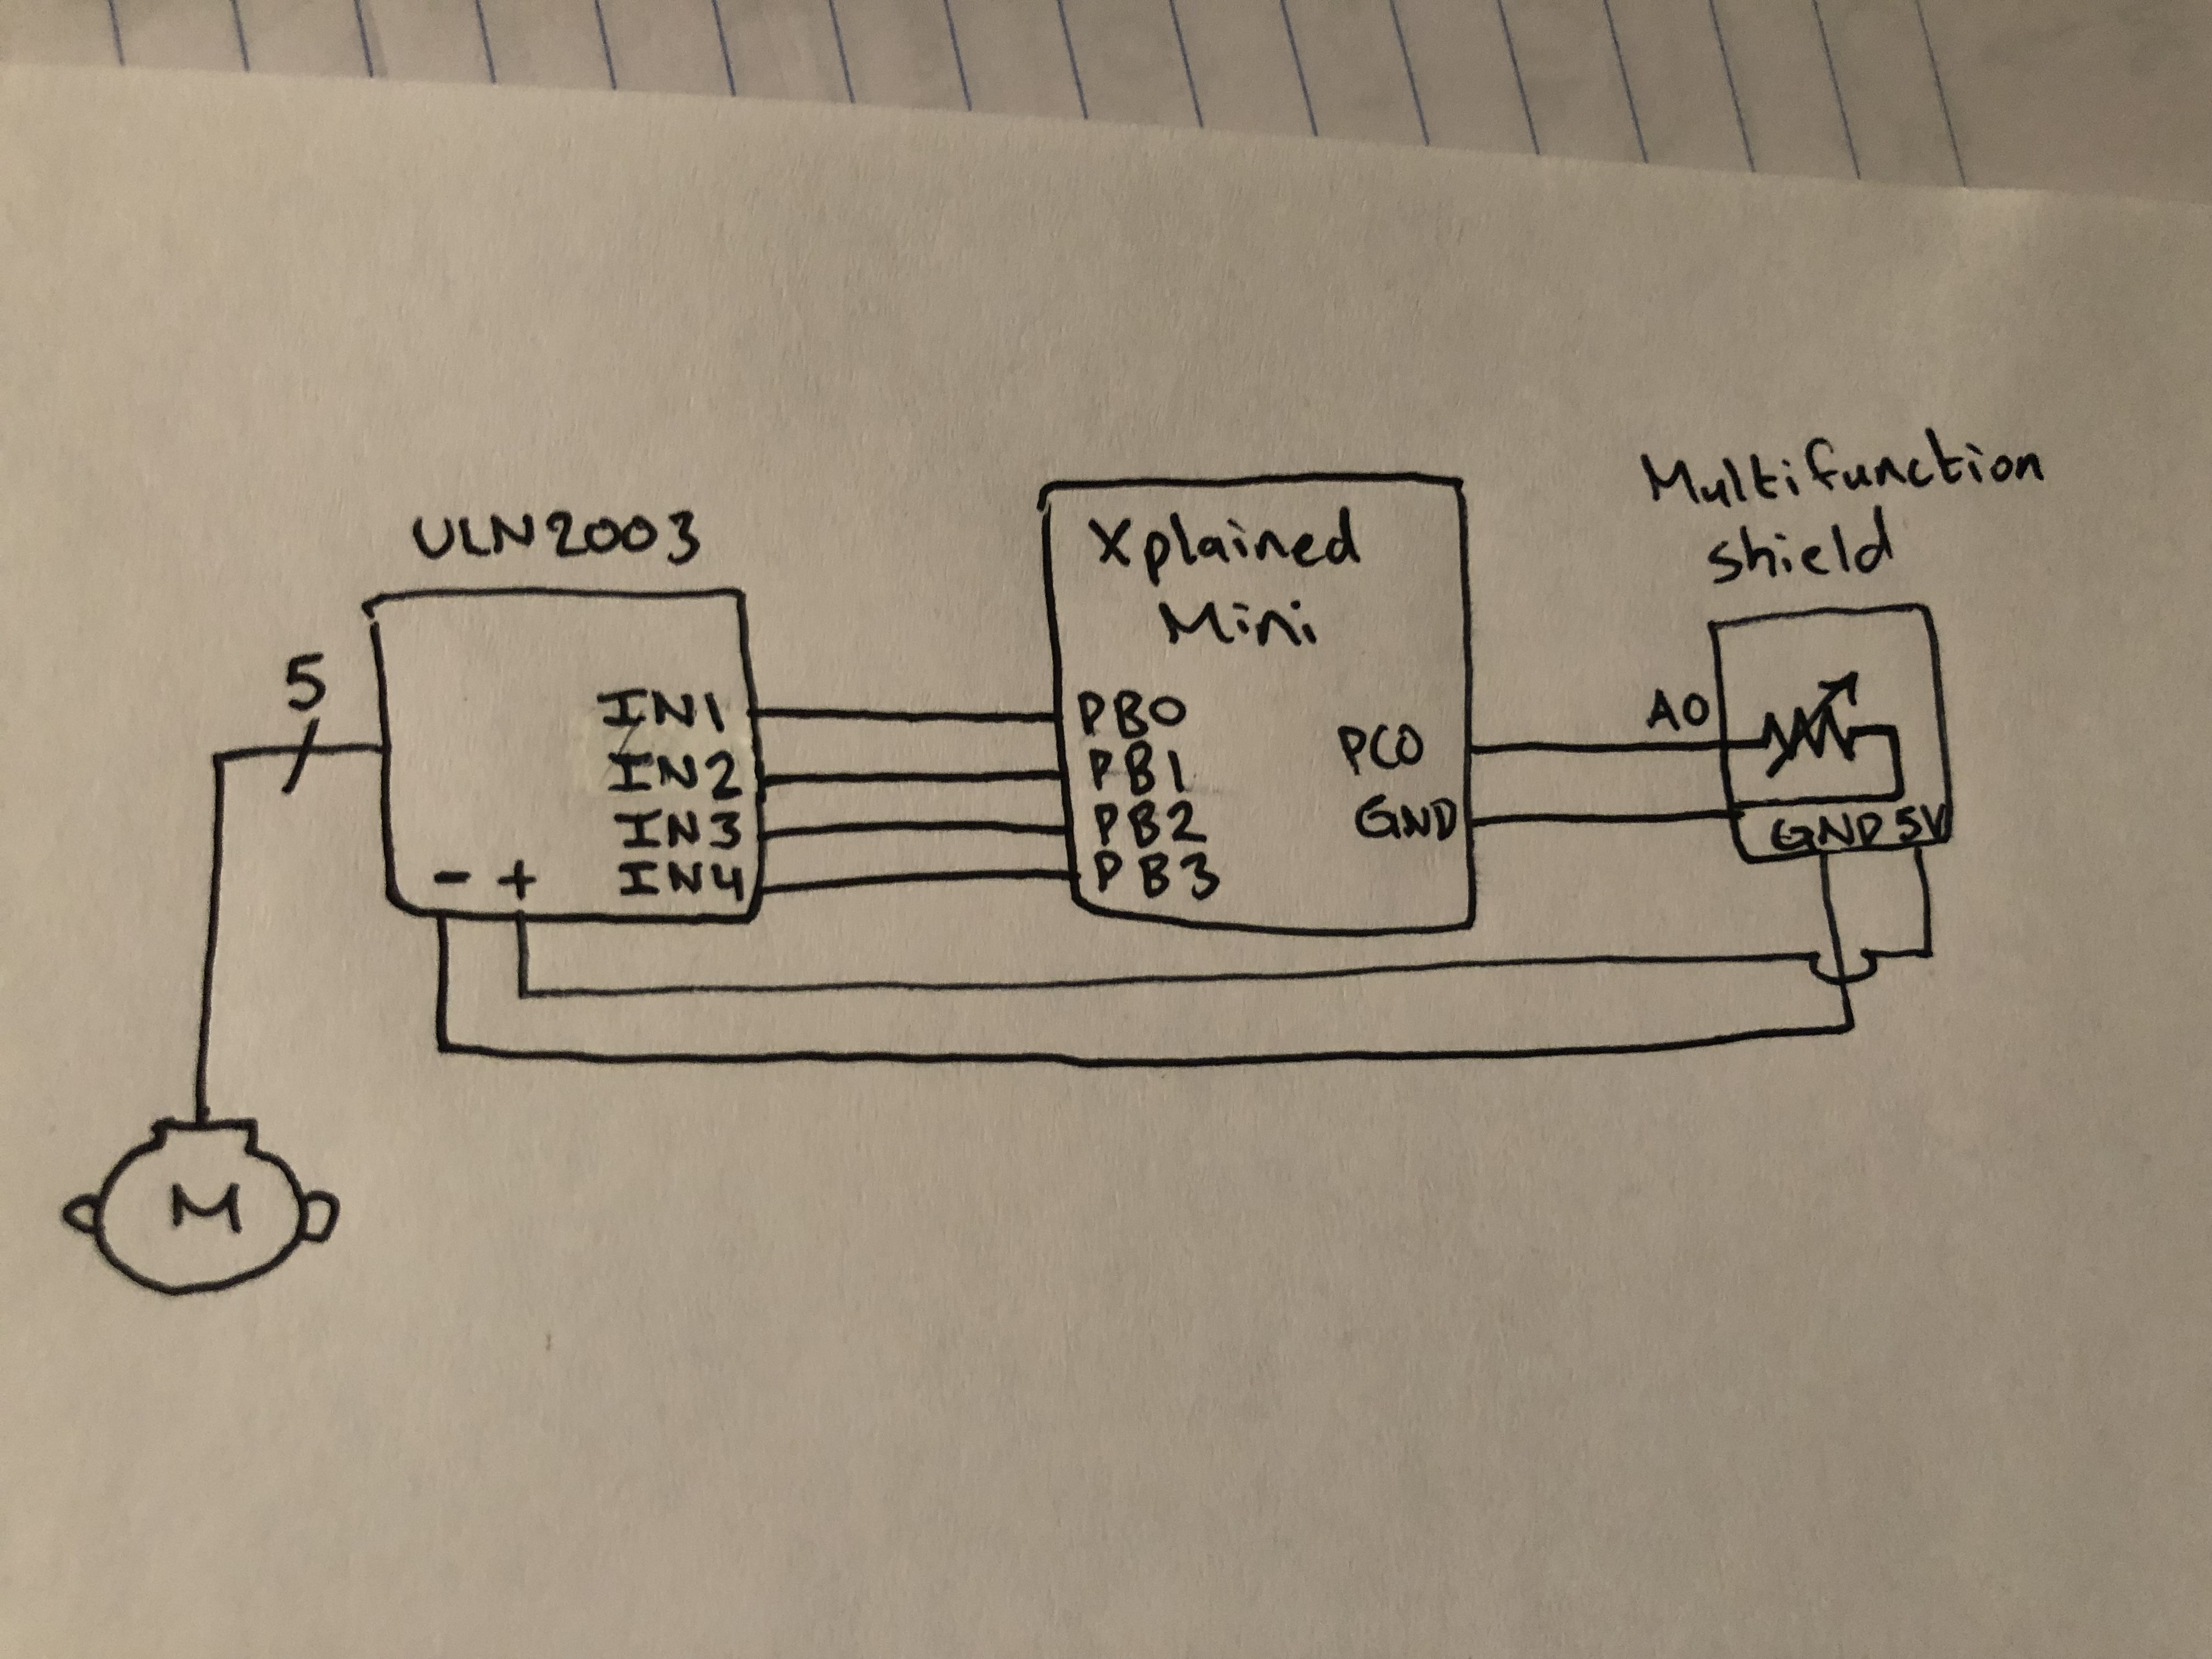

*Figure 3 – Schematic of Stepper Motor and Potentiometer ADC*

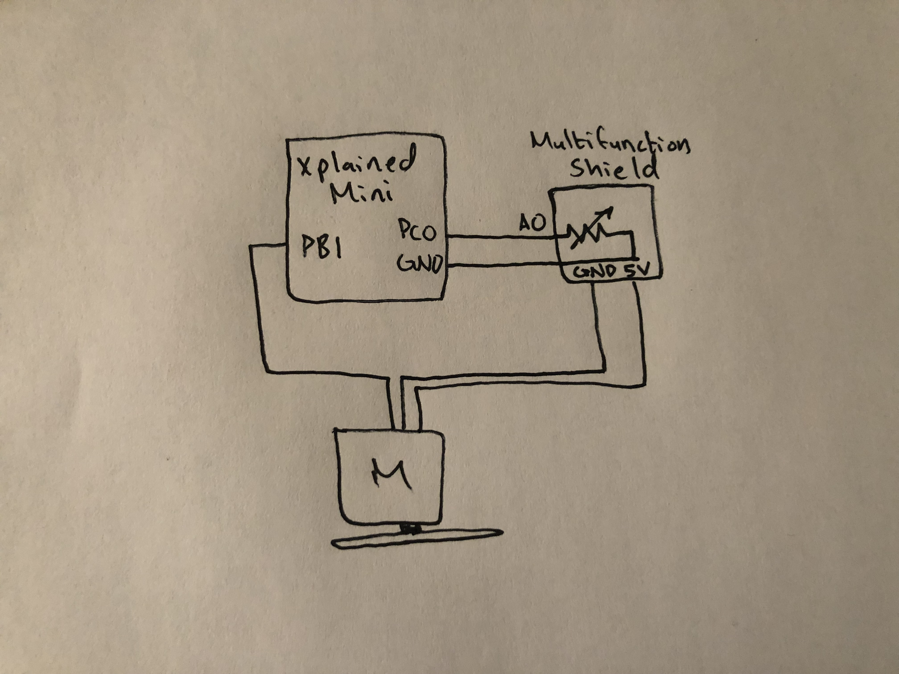

*Figure 4 – Schematic of Servo Motor and Potentiometer ADC*

1. **SCREENSHOTS OF EACH TASK OUTPUT (ATMEL STUDIO OUTPUT)**

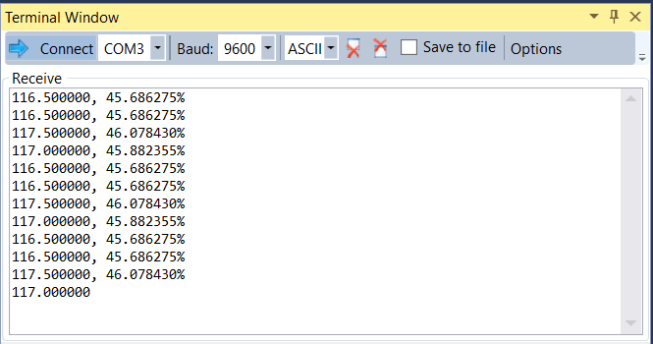

*Figure 5 – Output Terminal for Controlling Stepper Motor*

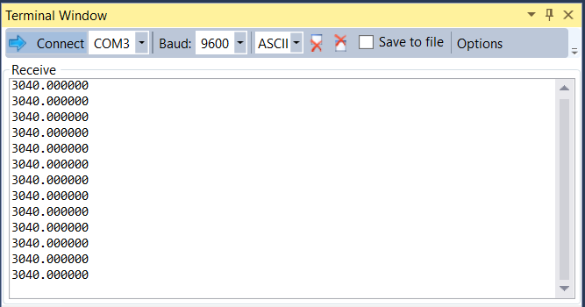

*Figure 6 – Output Terminal for Controlling Servo Motor*

1. **SCREENSHOT OF EACH DEMO (BOARD SETUP)**

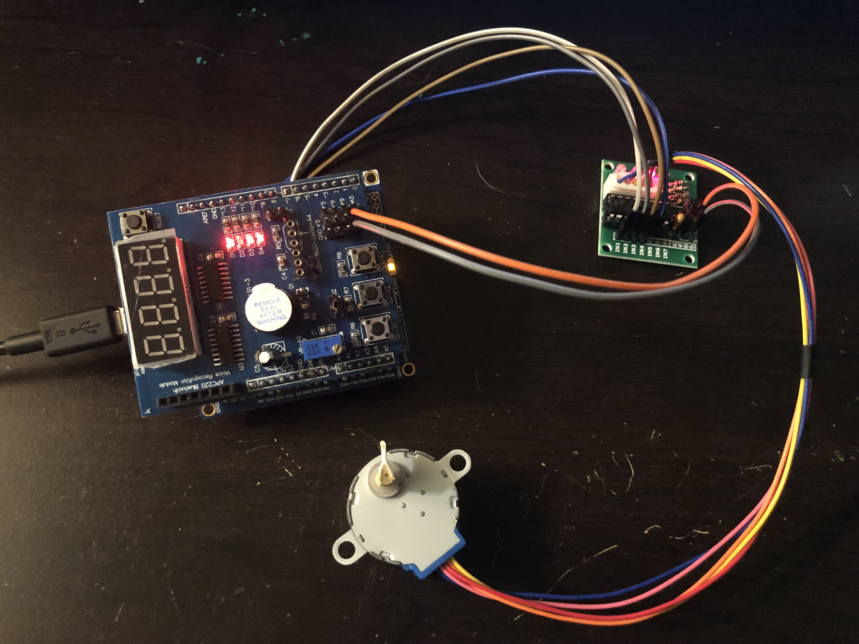

*Figure 7 – Connecting Stepper Motor to Potentiometer*

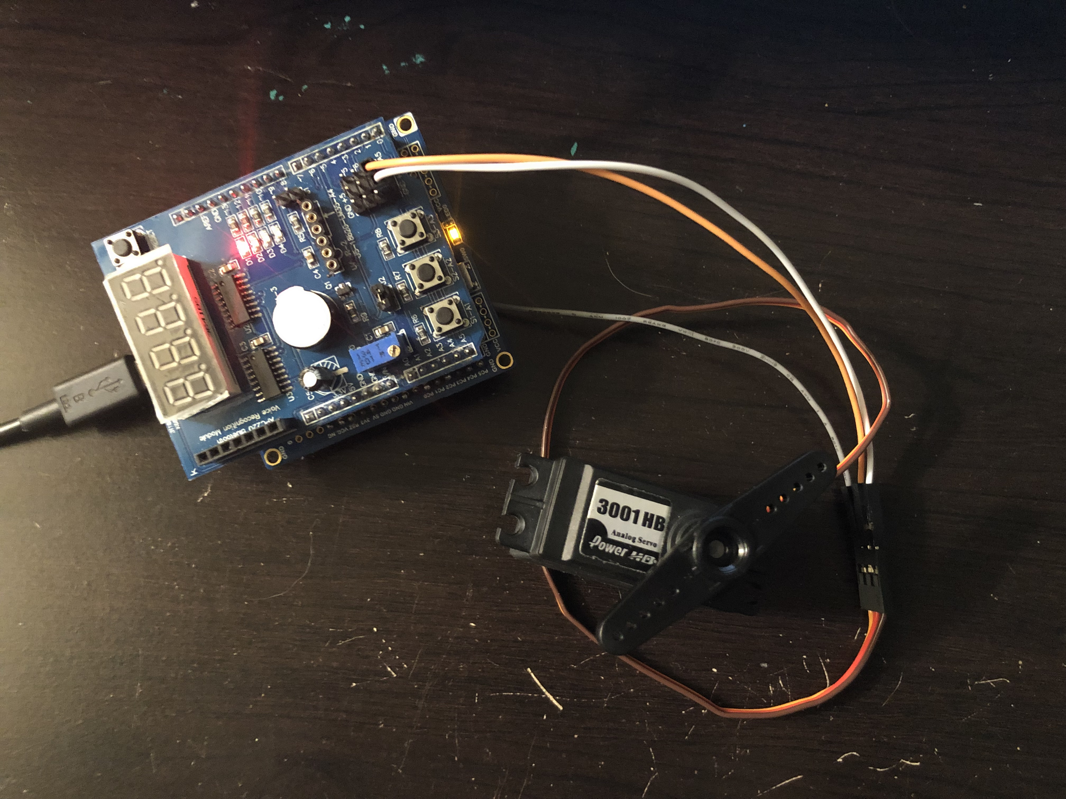

*Figure 8 – Connecting Servo Motor to Potentiometer*

1. **GITHUB LINK OF THIS DA**

https://github.com/katmando/asdfghjkl/tree/master/DesignAssignments/DA4B

**Student Academic Misconduct Policy**

<http://studentconduct.unlv.edu/misconduct/policy.html>

“This assignment submission is my own, original work”.

Alex Cater